Dear Parents and Members of Advanced Chorus,

This coming week finds us in our last preparations for our performance of The Messiah with Manchester University singers and orchestra. For parents and family members wishing to attend, tickets are $10 for adults and students 18 and younger are free. The performance will be held at Manchester University’s Cordier Auditorium at 3 PM on Sunday, December 6th. Transportation to and from Manchester University has been arranged and a schedule appears below. If any singer would like to ride home with their parents after the Sunday performance you MUST return the alternate transportation slip below.
A schedule for this week’s rehearsals and the performance information appears below:

Thursday, December 3. Rehearsal at FHS
6:00 PM – 9:00 PM

Saturday, December 5. Dress rehearsal at Manchester University
Bring a sack lunch…we will not be stopping to eat.
8:45 AM Meet at school
9:00 AM Depart for MU
10:00 AM Rehearsal
12:30 PM Leave for Fairfield
1:30 PM Return to Fairfield

Sunday, December 6. Performance at Manchester University
Eat before you come…again, there is no meal provided.
11:50 AM Meet at school
12:00 PM Depart for MU
1:00 PM Brush-up rehearsal before performance
3:00 PM Performance
4:30 PM Bus back to Fairfield
5:30 PM Return to Fairfield

Remember to spend time practicing with the rehearsal tracks provided by Dr. Lynn. The link to that resource is http://djlyn9.wix.com/musymphchorus

I hope that you all had a wonderful Thanksgiving. See you Monday!

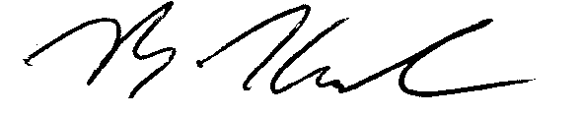

Ben Kambs
FHS Director of Choirs
574-831-2184, x. 8638
bkambs@fairfield.k12.in.us
------------------------------------------------------------------DETACH HERE----------------------------------------------------------------
I grant my child ___________________________________________ permission to use alternate
transportation home from Manchester University on 12/6/15.
_________________________________
Parent Signature

