Vocal Music Department
Fairfield Jr./Sr. H.S.
Ben Kambs, Director of Choirs

TO: Advanced Choir and their Parents
FR: Mr. Kambs
RE: FINAL SCHEDULE: State Qualification Contest, 4/30/2016

Students should arrive at Fairfield by 8:00 AM for an 8:30 AM departure. You must be responsible and ON TIME!! Be sure that you are wearing your concert attire when you arrive, and that you have all of your accessories (jewelry, shoes, bow ties, vests). A schedule for the day follows below:

All times are Eastern

8:00 AM Report/warm-up
8:30 AM Bus to Valparaiso High School
10:20 AM Arrive
11:05 AM Warm-up
11:30 AM Perform
11:55 AM Sight-read
12:25 PM Pack up and head home

If you need to leave the contest with your parents, you may fill out the form below and have them sign. If you ride the bus back, you should return by 2:15 PM. Let me know ASAP if you are returning with parents. Those who return on the bus should bring a sack lunch. YOU MAY NOT DRIVE YOURSELF TO OR FROM THIS EVENT!! It is a violation of our school’s liability policy and it is not acceptable. Return these alternate transportation forms to me by THURSDAY 4/28/16. This is required so that I can communicate with our transportation secretary what our bus arrangements will be. Be on time, be focused and responsible. Let’s make it a great day, free of stress and worry. Following procedures will allow us to focus on what’s important…making amazing music!

Thanks,

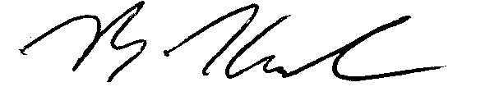

Ben Kambs
Director of Choirs
(574)831-2184
bkambs@fairfield.k12.in.us

---------------------------------------------------(Detach)----------------------------------------------
RETURN THIS SLIP BY THURSDAY, April, 28th!

I grant my child ____________________________ permission to use alternate

transportation on the return trip from Valparaiso High School, Saturday, April 30th, 2016.

My child will ride with __________________________________

______________________________________ ______________________________
Parent Signature Date

